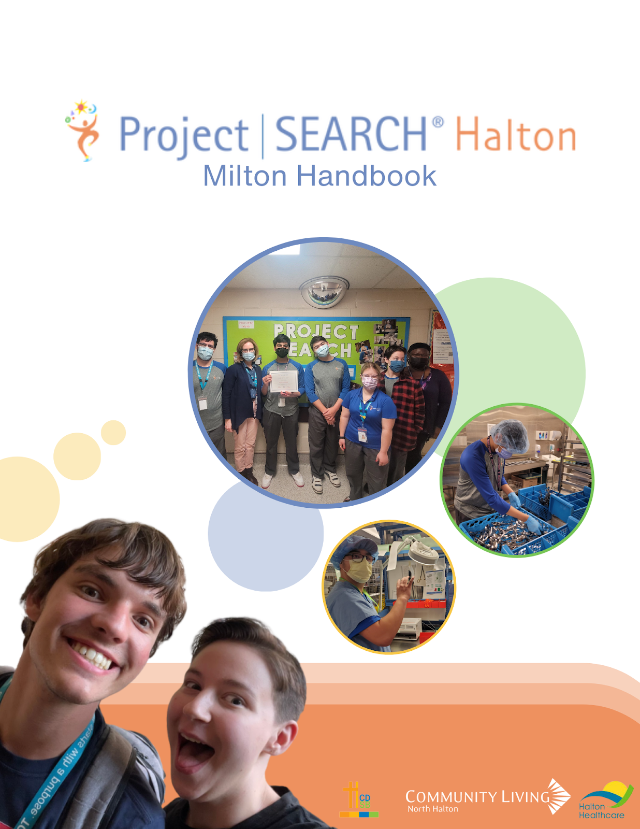

Project SEARCH Milton Handbook

A collaboration between:

Halton Catholic District School Board, Community Living North Halton and Halton Healthcare.

Instructor: Tracey Tapper tappert@hcdsb.org
Phone: (905) 878-2383 ext. 7998

Skills Trainer: Sophia Tate state@clnh.on.ca
Phone: (365) 822-2513

Skills Trainer: Snooky James sjame1@clnh.on.ca

Skills Trainer: Peace Ikpe pikpe@clnh.on.ca

Job Coach: Lesley Bullied lbullied@clnh.on.ca
Phone: (905) 875-7407

Table of Contents

What is Project SEARCH?

Roles and Responsibilities and Expectations of the Intern
Roles and Responsibilities of the Instructor
Roles and Responsibilities and of the Skills Trainer
Roles and Responsibilities of the Manager
Roles and Responsibilities of the Job Developer
Roles and Responsibilities of the Host Business Liaison
Roles and Responsibilities of Parent/Guardian

What is Project SEARCH?

Project SEARCH is a unique school-to-work training program for students with disabilities. Students are immersed at a host business and get more than 700 hours of hands-on work experience geared to in-demand roles in the local labour market. They learn employability skills and plan their careers with guidance from a teacher and skills trainers. A local employment agency supports graduates and their employers.
Project SEARCH Milton is a collaboration between Halton Catholic District School Board, Community Living North Halton and Halton Healthcare.
Project SEARCH believes in the participation of parents and guardians to help interns be successful.
Responsibilities and Expectations of the Intern:
- Participation in travel training to the Project SEARCH program, if required
- Participates in career exploration and discovers areas of interest
- Follow Rules and Regulations at host business including employee code of conduct
- Attends daily classroom instruction and strives for perfect attendance
- Interviews for internships
- Responsible for calling in if absent or late to teacher and internship manager
- Responsible for dressing appropriately, wearing uniform if required for internships
- Responsible for maintaining proper hygiene and grooming
- Attends job induction and training as scheduled with immediate supervisor
- Works with mentor, supervisor, teacher and job coach to successfully complete internship
- Adjusts to each internship and from intern to employee role
- Communicates with all team members any work-related issues
- Learns and practices employability skills
- Knows key contact people and uses information to help solve problems when issues arise
- Uses natural resources and supports
- Actively participates in job search towards paid employment
- Communicates with family regarding progress in Project SEARCH program

Special Education Consultant Roles and Responsibilities: Halton Catholic District School Board

- Provides overall support for Project SEARCH program: educational/career related visits, curriculum, supplies, etc.
- Assists with intern recruitment and selection
- Responsibility for compliance with school practice
- Provides administrative support for professional development for instructors, etc.
- Participates in the Steering Committee and Business Advisory Council
- Assists with data collecting and reporting at the system level
- Ensures that Project SEARCH interns have school liability insurance
- Develops recruitment materials for program
- Assists with problem solving and continuous improvement of program

Roles and Responsibilities of the Instructor: Provided by Halton Catholic District School Board
- Planning and teaching the Project SEARCH Employability Skills curriculum
- Assisting student interns with interviewing skills and resume and portfolio development
- Coordinating and implementing the Employment Planning meetings to be held at least twice during each internship
- Completing the Vocational Fit Assessment for the student interns and internships with the skills trainer(s), sharing the information with the team, and applying the results for meaningful internship selection and final job development
- Developing internship sites with the business liaison and skills trainer
- Ensuring that the student interns learn competitive, marketable, transferable skills and achieve maximum productivity and quality while on their internships
- Developing work accommodations and work aids with the skills trainer
- Evaluating each student intern’s progress and filling out required documentation for partners, funders, and the Project SEARCH database
- Providing employer education about disability awareness and supervising people with disabilities
- Recruiting student interns for the next Project SEARCH class and creating a pipeline of potential candidates
- Ensuring that student interns are eligible for long-term support, SSI, and other appropriate community, provincial, and federal supports
- Advocating for and facilitating internal job development at the host business
- Developing relationships with potential community employers
- Marketing the program within the host business and to the wider community
- Interacting with the student interns’ family members/caregivers

Role and Responsibilities of the Skills Trainer: Provided by Community Living North Halton

- Systematic Instruction to teach and break down essential tasks/duties/core skills of the job to the intern
- Building natural supports
- Developing accommodations
- Identifying appropriate assistive technology
- Skills Trainer must communicate effectively with other skills trainers, internship department managers/mentors, co-workers, support systems, and school and agency personnel as it relates to the student being trained
- Skills Trainer position requires specific task analysis assistance with vocational evaluations, and development of job coaching plans.
- Shares instructor role as needed i.e. planning and teaching the Project SEARCH Employability Skills curriculum
- Assists with travel training with interns when using public transport
- Participates in basic job coach training and continual staff development
- Maintains basic up to date knowledge of work-related benefits and funding support
- Practices good supported employment from providing Systematic Instruction to building natural supports for interns from their co-workers
- Works with instructor to assess student skills and gather baseline data
- Works with business liaison, department managers, instructor and fellow job coaches to develop internship sites, write job descriptions, task lists, job analysis and plan for Reasonable Adjustments for the internships and competitive jobs
- Works with managers and co-workers to educate on disability awareness
- Reinforces employability skills and assists intern to understand protocol and interpret work culture
- Assists in training intern in interview process (unique to each host business) in order for interns to gain both internships and competitive posts
- Learns the internship duties and makes any Reasonable Adjustments (e.g. labels cabinets, simplifies written instructions, etc.) necessary to the successful completion of the job
- Attends job induction with the intern and clarifies information with the intern as necessary

Role and Responsibilities of the Manager: Provided by Community Living North Halton

- Appoints Project SEARCH job coach/job developer
- Manages and oversees Skills Trainers
- Provides support for Project SEARCH Transition Program: eligibility of interns for adult supported employment, timely job development, training, supplies, etc.
- Assists with intern recruitment and selection
- Provides administrative support for: resume building, data collection, professional development for job coaches/developers, etc.
- Participates in the steering group
- Assists with data collection and reporting
- Develops marketing materials for program
- Assists with problem solving and continuous improvement of program

Roles and Responsibilities of the Job Developer/Coach: Provided by Community Living North Halton
- Attends employment planning meetings to know interns’ strengths, interests and challenges in preparation for job development
- Provides sector information to the Project SEARCH team as individual interns develop career goals i.e. specific core skills and experiences required in job applicants
- Works with intern and all team members to locate competitive employment based on individual strengths and skills
- Explores jobs at locations outside host business site
- Explores specific job possibilities at external businesses for interns not employed at host site
- Keeps all team members informed of potential jobs
- Performs job analysis and job matches
- Coordinates job coaching eligibility
- Problem solves issues as they arise
- Produces necessary reports and data for Project SEARCH and other partners

Host Business Liaison Roles (Milton District Hospital) and Responsibilities

- Coordinates base training space, furniture and equipment
- Supports and participates in the intern selection process
- Works with instructor and job coach to develop internship sites, job descriptions and Reasonable Adjustments
- Facilitates induction process for instructor and job coach
- Arranges for and assists with detailed job induction and training to the intern
- Helps to identify a department mentor at each intern site
- Assists with interview process for interns before their job rotations
- Assists with disability awareness and educational presentations to the internship departments
- Hosts events to promote and market the program internally and externally – intern induction, Open House, Information Night, graduation, other celebrations
- Reinforces workplace rules for interns
- Conveys a positive attitude about Project SEARCH to the whole organization and in the community
- Interacts with Project SEARCH staff and interns on an ongoing basis
- Networks with departments within the organization such as Public Relations, Communication, Diversity, and Human Resources to promote the program and increase the opportunity for employment
- Assists with evaluation/feedback instrument for the interns
- Assists with problem solving intern and other program development issues
- Serves on the Project SEARCH steering group
- Markets Project SEARCH to the host organization and in the community
- Initiates/participates in the Business Advisory Committee to increase networking and career opportunities (industry focused - made up of community employers)
- Involved in continuous improvement of Project SEARCH
- Hosts tours of Project SEARCH
- Addresses union issues when appropriate

Parent or Guardian Roles and Responsibilities
- Provide on-going assistance to intern as they work towards job goals
- Supportive of intern using public transport when available; assists with travel training; assists with transport to Project SEARCH and job, if needed
- Assists the intern in developing independent personal care
- Assists the intern with achieving attendance and other appropriate employability skills
- Participates in employment planning meetings to discuss students’ issues, progress, etc.
- Addresses any issues and concerns regarding student progress by working with intern at home
- Follows through on eligibility with appropriate agencies
- Communicates with instructor, job coaches/job developer and/or career advisor regarding any concerns – does not communicate directly with any host business personnel
- Collaborates with other team members for overall intern transition process
- Promotes intern’s personal development

ORIENTATION

- On orientation day, interns and their parents/guardians will be introduced to the Project SEARCH classroom, receive an introduction to the hospital and possible internships. Interns will also receive their uniforms.

RESPECT

- We will be discussing this very important topic throughout your Project SEARCH year. Respect is intertwined in everything we do and say to each other. Please remember that we must take into consideration the feelings, wishes, rights, or traditions of others.

UNIFORMS

- Your Project SEARCH uniform MUST be worn everyday unless told not to. This also includes your no slip safety shoes, hair net, mask and gloves, if required, these are all mandatory parts of your uniform.

CLASSROOM COMPUTERS

- All Project SEARCH interns will have a computer at their desk. It is the responsibility of the intern to make sure their computer is used appropriately, which means NO online gaming or inappropriate downloads. All computers are owned, maintained and updated by Halton Healthcare and access will be taken away if not used appropriately and responsibly.

ABSENCES

- If you are away from class or your internship, YOU must notify your mentor and or manager, instructor and school to let them know you will be away. This will be YOUR responsibility.

- If you are running late to class, please make sure you notify your instructor by calling, email or text. This is very important as daily attendance is taken.

IDENTIFICATION BADGES

- This badge will be given to you on your first week of class, it is a part of your required uniform. You MUST wear your ID badge everyday while working.

APPEARANCE/HYGIENE

- Personal hygiene is mandatory in everyday life. Interns must ensure their uniform is clean, hair is to be combed, groomed and maintained. Deodorant should be used and brushing of teeth should be daily. If relevant, facial hair should be neat.

MEDICATION

- The Project SEARCH team must be informed about anyone requiring to take medication while participating in the program. The instructor must organize with parents and associated school the documentation required to administer medication.

CAFETERIA/TIM HORTONS

- As interns, you will have access to the lunch area at the main entrance of the hospital. You are permitted to have your lunch there. Alternatively, weather permitting, you can go outside; or have lunch in the lunchroom on your unit. You are able to buy your lunch or bring it from home.
- While eating in the main lunch area, please remember that you are representing Project SEARCH. Please clean up after yourself and refrain from wandering around the hospital.

THEFT

- Theft of any sort will result in the intern being removed from Project SEARCH

CELL PHONES

- Interns are permitted to use their cell phones on breaks, lunch time, and in the case of emergency situations (ie. sick and need to contact parent/guardian to arrange pick up).
If cell phones are used at inappropriate times (ie. on the unit while working), interns will be directed to leave their cell phones in the classroom when completing their internship.

Sexual Harassment and Violence
Halton Catholic District School Board (Policy No.III-05, III-15, III-16)
The Ontario Human Rights Code, Community Living North Halton and Halton HealthCare prohibits sexual harassment, and violence of any kind. If an intern is found to have participated in these actions, they will be terminated from Project SEARCH and the proper authorities will be notified.
Sexual harassment is any unwanted comment, gesture, or action that is sexual in nature (aside from unwanted touching of sexual body parts, which is sexual assault), that makes someone feel afraid, embarrassed, uncomfortable, or ashamed. The intention of the person doing the action does not matter; it’s the negative impact the action has that makes something sexual harassment.
any intern participating in these behaviours will be withdrawn from Project SEARCH

Other Forms of Harassment
- Making unwelcome remarks or jokes about a person’s race, religion, sex, age, disability or any other grounds of discrimination
- Threatens or intimidates a person because of their race, religion, sex, age, disability, or any other grounds of discrimination
- Making unwelcome physical contact with a person, such as touching, patting, or pinching.
any intern participating in these behaviours will be withdrawn from Project SEARCH
Violence
Violence is the use of physical force to cause harm to people, animals, or property- such as pain, injury, death, damage, or destruction.
any intern participating in these behaviours will be withdrawn from Project SEARCH

Glossary
Job Developer
A job developer is responsible for seeking out or creating jobs for potential candidates.
Intern
A student who rotates through various work placements in order to gain work experience.
Job Coach
Someone who supports an employee on the job. A job coach provides customized and flexible support to the employee in learning the tasks and responsibilities of the job.
Inappropriate Behaviour
Inappropriate behavior means conduct that is unwarranted and is reasonably interpreted to be demeaning or offensive.
Theft
Taking something that does not belong to you.
Hygiene
Hygiene is the practice of keeping yourself and your surroundings clean; especially in order to prevent illness or the spread of diseases.

Skills Trainer
The Skills Trainer provides individualized support for interns during the internship rotation in order for the intern to acquire competitive and marketable skills.

Respect
Respect means that you accept somebody for who they are, even when they're different from you, or you don't agree with them.

